**Task : Static Website Hosting with S3 Bucket**

**Login to AWS console and Go to the S3 service**

**Create bucket with configuration- ACL enabled and allow public access with unique name**

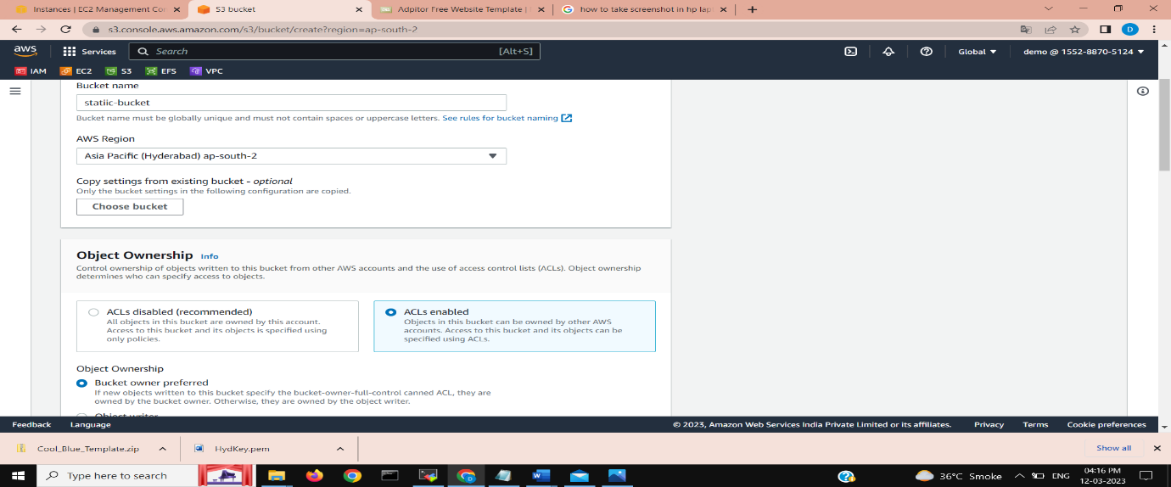

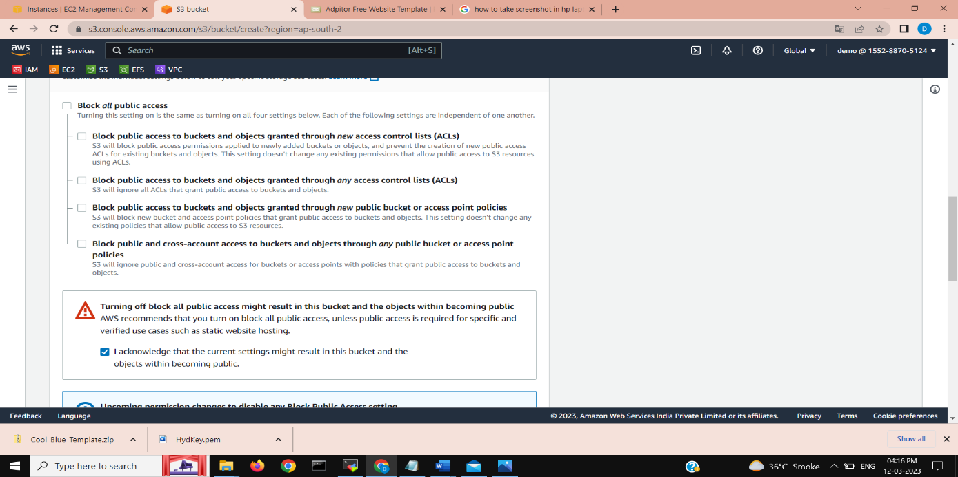

**Click on upload Button, and upload required files of static website**

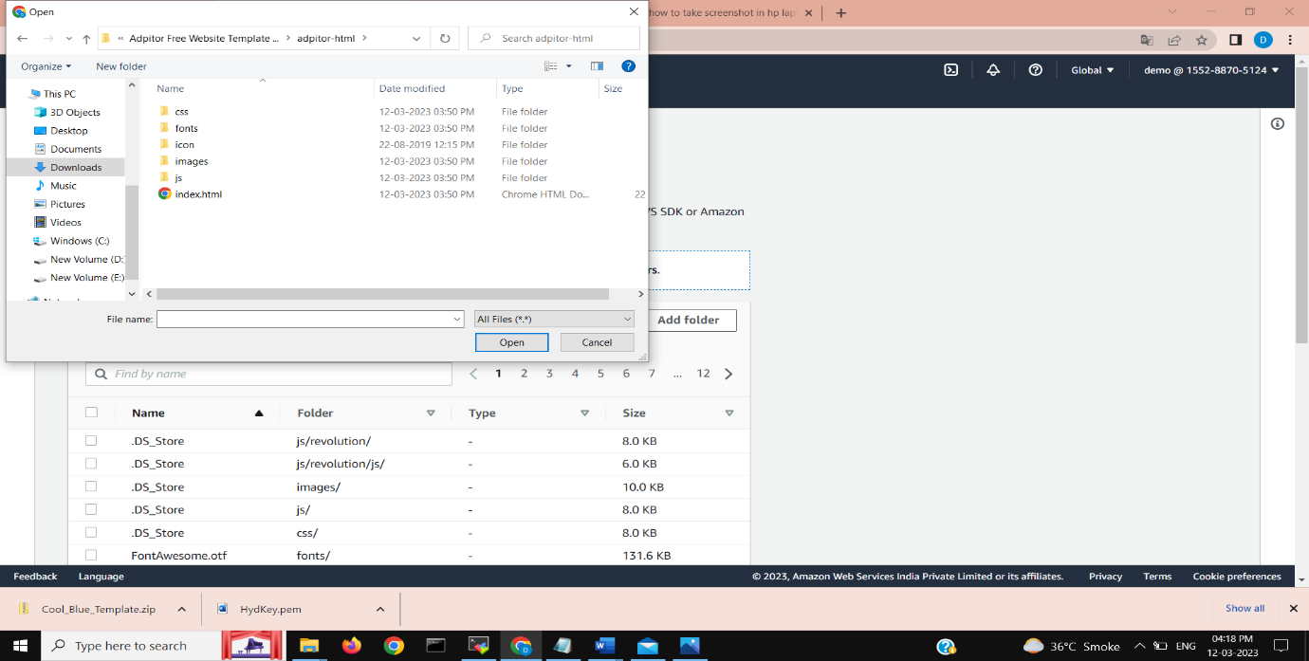

**Click on properties to make required changes**

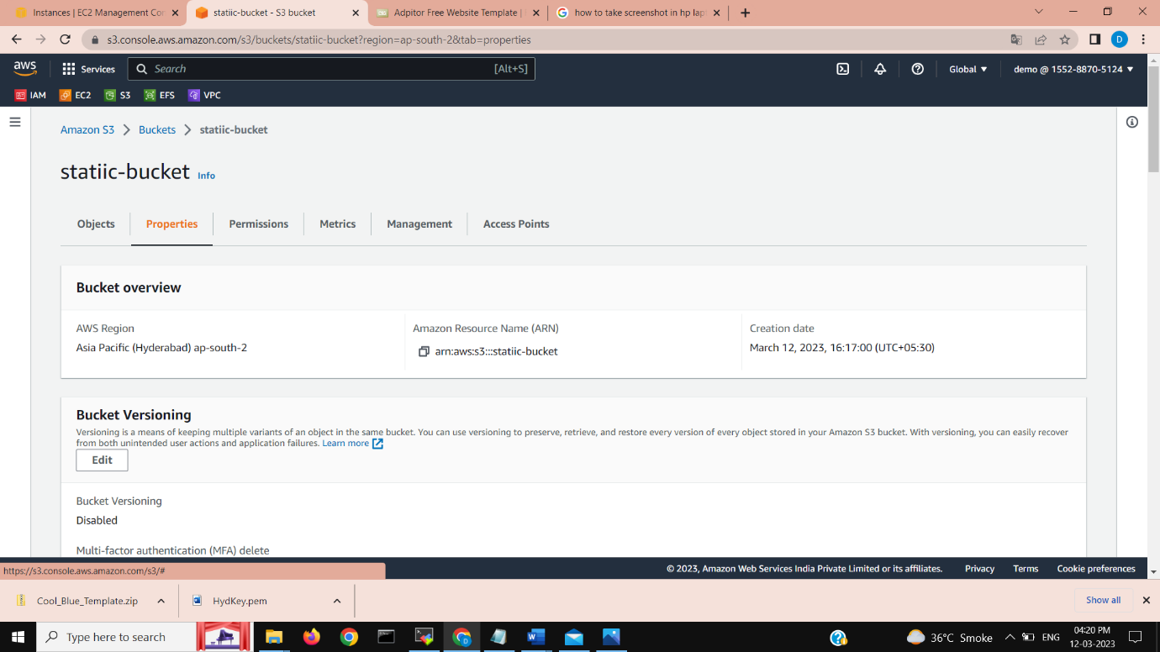

**Click on edit static website hosting**

**Make it enable**

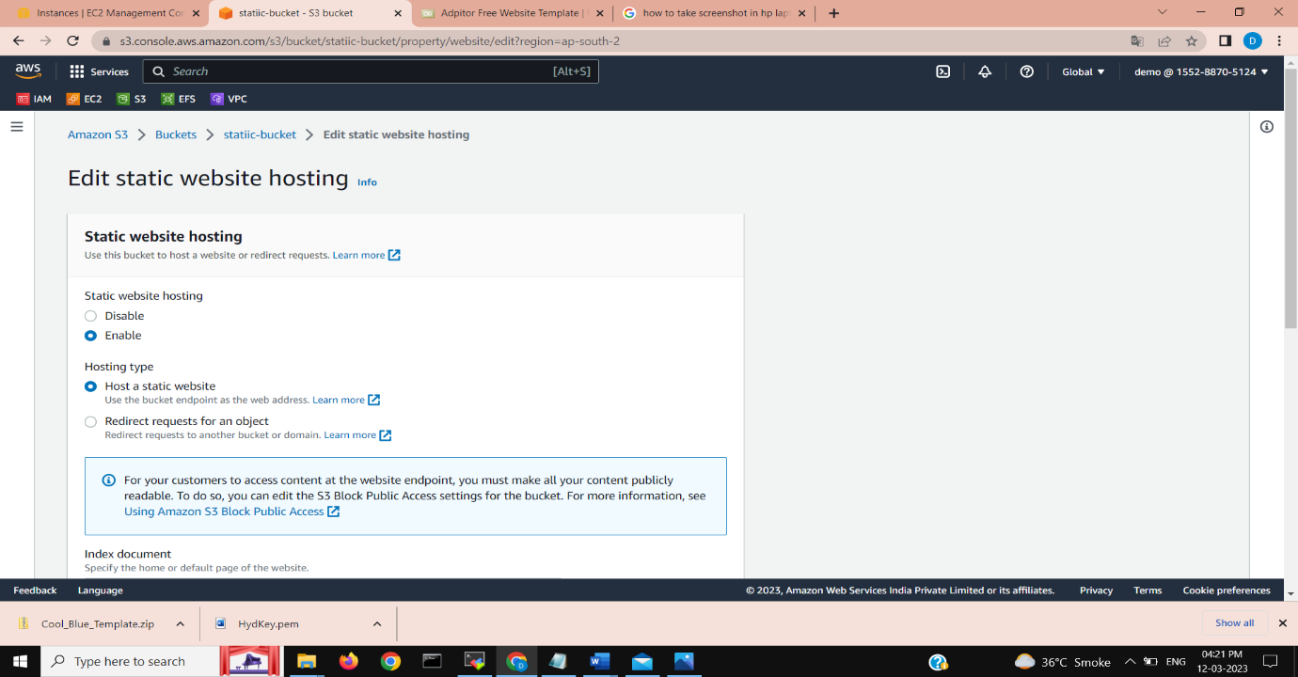

**Go to permission and create bucket policy for static website or paste it from internet**

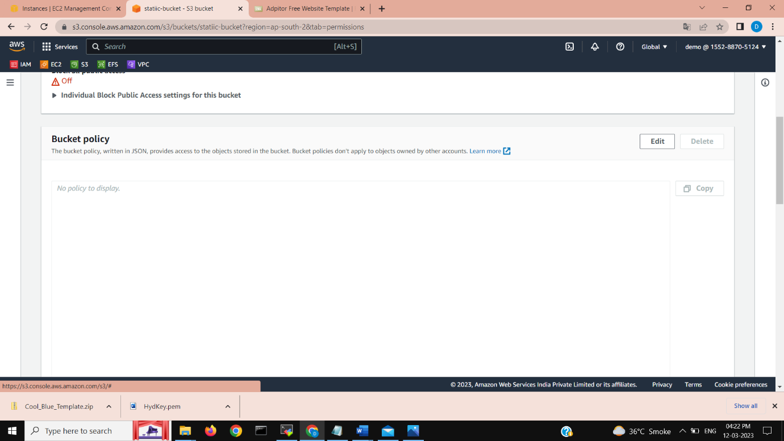

**Click again to properties -> static website hosting and copy URL and hit it at internet**



